Tech Law Clinics

Report of Activities at Radboud University

Academic year 2019/2020

Contents
1. Recruitment of students 1
2. Adaptation of the case-study 1
3. Outline of lectures and meetings conducted at Radboud University 2
3.1. Lectures 2
3.1.1. 11 December 2019: Lecture on algorithmic discrimination 2
3.1.2. 21 January 2020: Lecture on written and oral advocacy 2
3.1.3. 6 February 2020: Lecture on algorithm de-biasing 2
3.1.4. 2 March 2020: Lecture on Direct Horizontal Effect of the Charter of Fundamental Rights 2
3.2. Team Meetings 2
3.3. Spring School Organizational Meeting 3
4. Drafting of written memoranda and judgment 3
5. Visit to associated partner 3
6. Simulated hearing 4

Recruitment of students
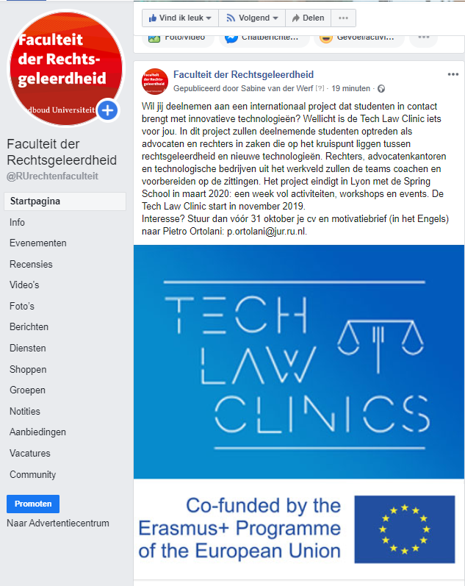
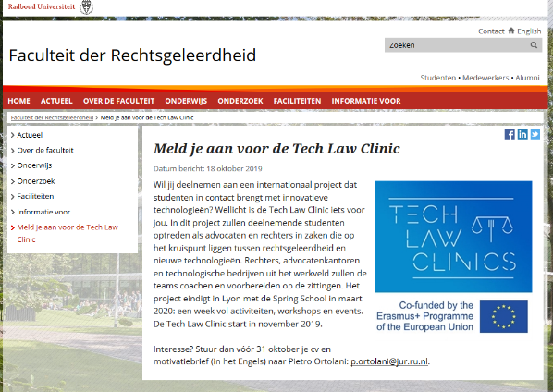
During the month of September, a number of efforts have been undertaken, in order to promote the Clinic among the students. Posters and leaflets were printed, and posts were published on the University’s websites and social media accounts, such as Facebook and Instagram. In addition, presentations were made during a number of classes, both at the Faculty of Law and at the Faculty of Sciences. In particular, the students of the following courses were addressed in person by Dr. Pietro Ortolani:
- International Arbitration;
- Introduction to Topics Typical to Dutch;
- Private International Law;
- Data Protection (course led by Prof. Frederik Borgesius at the Faculty of Sciences).
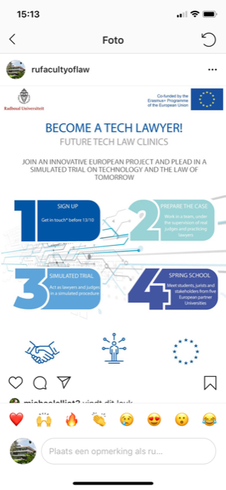
These promotional efforts yielded sufficient results. A total of 23 applications were received. All candidates submitted an application and a CV, and all of them were invited to an individual interview of approximately 30 minutes. During the interview, the candidates’ legal and/or technical background was tested, together with language skills and personal motivation. As an outcome, 20 candidates were selected, in accordance with the tender specifications. The male/female ratio among the selected candidates was exactly 50%, with 10 male and 10 female students.

Adaptation of the case-study
The months of October and November 2019 have been devoted to the adaptation of the case-study concerning algorithmic discrimination and self-driving vehicles (provided by the Catholic University of Lyon) to the specific teaching needs of Radboud University. The adaptation posed a twofold challenge. First of all, it was necessary to adapt the problem to the specificities of Dutch law, which contains some peculiar provisions (for instance, on the possibility of obtaining compensation for moral damages). Secondly, it was also important to ensure that the problem would be interesting and understandable for the 3 foreign law students who did not have a background in Dutch law.
As a solution, the case-study was adapted into a procedural order, issued by a fictional court. In the order, the disputing parties were requested to focus on five main legal issues. Two of those issues revolved around art. 21 of the Charter of Fundamental Rights of the European Union. As such, they were suitable for those students lacking a background in Dutch law, but familiar with EU law. The other three issues, instead, dealt with Dutch law.

Outline of lectures and meetings conducted at Radboud University
A number of educational activities were conducted at Radboud University. Some of the activities were lectures, as detailed below, while other activities were student-led meetings, where the students were divided in teams and discussed the case-study from the perspective of the claimant, the respondent or the judges. In addition, some organizational meetings were conducted.

Lectures

11 December 2019: Lecture on algorithmic discrimination
The first lecture, given by Dr. Ortolani, dealt with the issue of algorithmic discrimination, as emerging from the case-study. The students were walked through the case-study and presented with a selection of relevant literature, comprising both legal and computer sciences texts. At the end of the lecture, the students were invited to self-enroll in one of the three teams (claimant, respondent, or judges), according to their preferences.

21 January 2020: Lecture on written and oral advocacy
The second lecture was delivered by Prof. Albert Henke (University of Milan and Clifford Chance, Milan). Prof. Henke presented the students with the basics of written and oral advocacy. The lecture was structured around the most common mistakes that counsels commit, when preparing a case. The students were given the possibility to ask questions and receive advice on the preparation of the case.

6 February 2020: Lecture on algorithm de-biasing
The third lecture dealt with the delicate problem of whether and to what extent algorithms can be built or modified in a way that minimizes the risk of bias, while at the same time maintaining accuracy. For this lecture, the computer sciences students were asked to deliver a presentation, illustrating some basic notions about the technical aspect of the algorithm around which the case-study revolves. Subsequently, Dr. Ortolani led a discussion with the group. The discussion was very fruitful, with numerous questions and interesting points being raised by both law and computer sciences students.

2 March 2020: Lecture on Direct Horizontal Effect of the Charter of Fundamental Rights
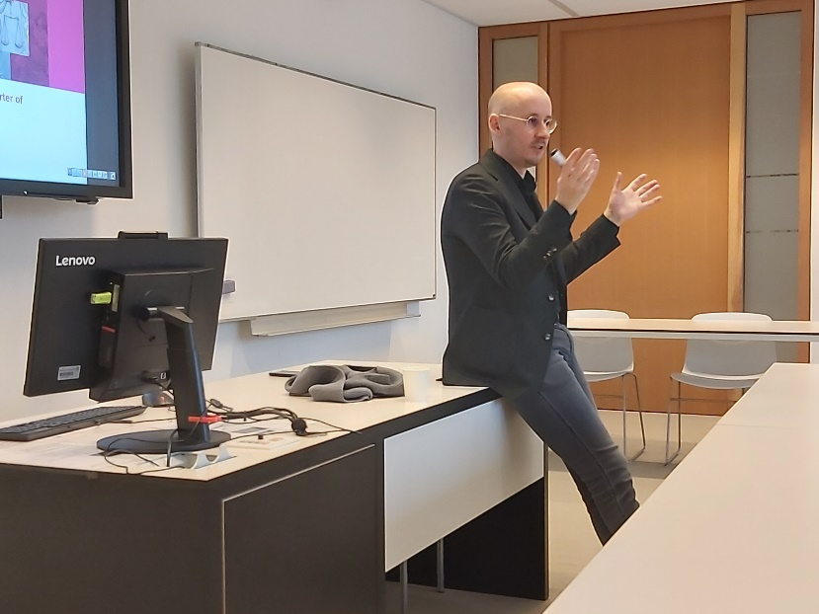
The fourth lecture was delivered by Dr. Roel van Leuken, judge at the Court of Appeal of Arnhem-Leeuwarden. Dr. van Leuken is one of the leading experts on the direct horizontal effect of primary EU law, having written a monograph on the topic. For this class, Dr. van Leuken analyzed the case-study, and gave the students a presentation of the key legal issues surrounding the direct application of the non-discrimination provisions of the Charter. Some students also expressed a wish to receive career guidance from a member of the judiciary, and Dr. van Leuken took the time to give them advice in this respect as well, after the class.

Team Meetings
The students scheduled weekly meetings with the members of the teams they belonged to (claimant, respondent, or judges). While the students were left free to organize the meetings at their convenience and according to their schedules, Dr. Ortolani supervised them and provided guidance where needed. Two types of activities, in particular, required supervision. First, the drafting of the written memoranda and of the judgment raised a number of issues. To address these issues, Dr. Ortolani asked all students to submit preliminary drafts, which were then discussed in person. Second, the preparation of the oral hearing required some guidance. To this end, Dr. Ortolani met the three teams separately, so as to ensure that the value of the hearing as a simulated experience would be preserved. Hence, three different “hearing briefings” were conducted, respectively on 27 February (team respondent), 28 February (team claimant), and 4 March (team judges). After these briefings, some students requested an individual meeting, to rehearse their oral pleading. These further meetings were conducted between 5 and 11 March.

Spring School Organizational Meeting
On 9 March, the students met with Dr. Ortolani and Ms. Loes Spiertz from the International Office of the Faculty of Law, to discuss the logistics of the Spring School. Originally, the aim of this meeting was to give the students some practical information about the flights, and transfers to and from the airports, and the accommodation. To this end, bundles with all the necessary information were created and distributed to each student. Unfortunately, however, the news about the spreading of the coronavirus gained prominence in the days before the meeting. For this reason, the meeting became also a chance for the students to meet with the project coordinator and with a member of the University administration, to discuss personal concerns and preferences. Having a meeting in person helped greatly in managing the students’ expectations, and giving them some personal guidance. It is a best practice that should be replicated, in the years to come.

Drafting of written memoranda and judgment
In the months of January and February 2020, the students were involved in the drafting of three documents related to the case-studies. The two teams acting as counsels for claimant and respondent drafted two statements, respectively of claim and defence. The judges, instead, drafted a judgment, deciding the legal dispute and in particular taking a position on the five issues identified in the procedural order on December 2019 (see above).
Each student sent their drafts to Dr. Ortolani, who commented on each draft extensively in writing. The students were then asked to address the comments in a new version of the drafts, and to collaborate with each other to ensure consistency among the different parts of the memoranda and judgment, and an efficient division of labour. Dr. Ortolani met with the students repeatedly, to ensure they grasped both the legal and the technical questions raised by the case-study. Once all students improved their individual drafts, the results were consolidated in the final documents containing the statement of claim, statement of defence, and judgment.

Visit to associated partner
The spreading of the coronavirus in Northern Italy has made the involvement of the associated partner we had originally envisaged (the start-up company Jur, based in Turin) excessively difficult. However, Prof. Janssen identified an alternative partner that could bring a significant added value to the clinic: the University of Applied Sciences Rhein-Waal, in Kleve (Germany). The University of Applied Sciences hosts a lab for the development and testing of self-driving technologies, which are crucial for the Clinic’s case-study. Prof. Dirk Nissing, the Dean of the University of Applied Sciences, agreed to host a visit to the lab, on 17 March. The logistics of the visit (bus travel, ticket fares etc.) were communicated to all participating students. However, on 12 March 2020, all educational activities and business trips were suspended by Radboud University, due to the spreading of the coronavirus. For this reason, the visit has been postponed, to a date to be determined once the emergency subsides.

Simulated hearing
The simulated hearing was scheduled for the morning of Friday 13 March. Dr. Ortolani made arrangements with three members of the University administration to film the hearing with four professional cameras and three high-quality microphones, so that the footage could then be processed according to the tender specifications. All students were briefed in preparation for the hearing (see above). However, as already mentioned, all educational activities were suspender on 12 March 2020. The hearing, therefore, is postponed to a date to be determined.

