Tech Law Clinics

Report of Activities at Radboud University

Academic year 2020/2021

Contents
1. Recruitment of students 1
2. Writing and translation of this year’s case 3
3. Planning of this year´s Spring School 3
4. Outline of lectures and meetings conducted at Radboud University 4
4.1. Lectures/meetings 4
4.1.1. 10 December 2020: Kick-off meeting 4
4.1.2. 17 December 2020: Lecture on international arbitration 4
4.1.3. 7 January 2020: Lecture on Online Dispute Resolution-mechanism (ODR) 5
4.1.4. 14 January 2020: Jur AG Court Layer Simulation 6
4.1.5. 21 January 2020: Smart Contracts and the new digital directives 6
4.1.6. 4 February 2020: Tokens and Fintech 7
4.1.7. 18 February 2020: Competition law and digital markets 7
1.1.1. 25 February 2020: EU data protection and security rights 8
1.1. Team Meetings 9
1.2. Spring School Organizational Meeting 10
2. Drafting of written memoranda and judgment 10
3. Visit to associated partner 10

Recruitment of students
In conjunction with political measures, the corona pandemic has led to the situation that no classic recruitment like last year could take place. Since very few events were physically held in Nijmegen, the recruitment had to be carried out mainly via digital channels. In the months of September and October we therefore carried out a hybrid recruitment. For this purpose we went to the individual physical lectures and took beside that part in Webex/Zoom events in order to introduce the project to as many students as possible. These presentations were caaried out in classes of the Faculty of Law and at the Faculty of Computer Sciences. During the month of September and October, a number of additional efforts have been undertaken, in order to promote the Clinic among the students. Posters and leaflets were printed and spread on the campus; posts were published on the University’s websites and social media accounts, such as Facebook and Instagram. A 5-minute promotional video was also shot and shared across the university's digital teaching platforms. In particular, the students of the following courses were addressed in person by Tom Vennmanns:
- Fundamental Rights in Europe
- Bankruptcy Law
- Private International Law;
- Private Law
- Labor law
- Philosophy of Law
- International arbitration
- Private procedural law
A total of 12 applications were received. Unfortunately, 20 students could not be mobilized like last year. This is obviously due to the general lack of motivation of the students caused by the restrictions of the pandemic. Many students do not see the hybrid form of such a project as an equivalent substitute to a completely physical event. Furthermore, in our experience, many students decide to postpone their study ambitions for the time after the pandemic. The great uncertainty of future developments and political restrictions then also leads to the students weighing up the decision not to register for such projects. In view of this, we are glad that we could recruit at least 12 students.
All candidates submitted an application and a CV, and all of them were invited to an individual interview of approximately 30 minutes. These interviews were carried out via Webex. During the interview, the candidates’ legal and/or technical background was tested, together with language skills and personal motivation. As an outcome, 12 candidates were selected, in accordance with the tender specifications. The male/female ratio among the selected candidates was exactly 50%, with 6 male and 6 female students.
Three students are computer scientists and nine lawyers. So we can fortunately form three teams with one computer scientist and 3 lawyers. The realization of the TLC in terms of the tender (interdisciplinary group exchange) is thus guaranteed.

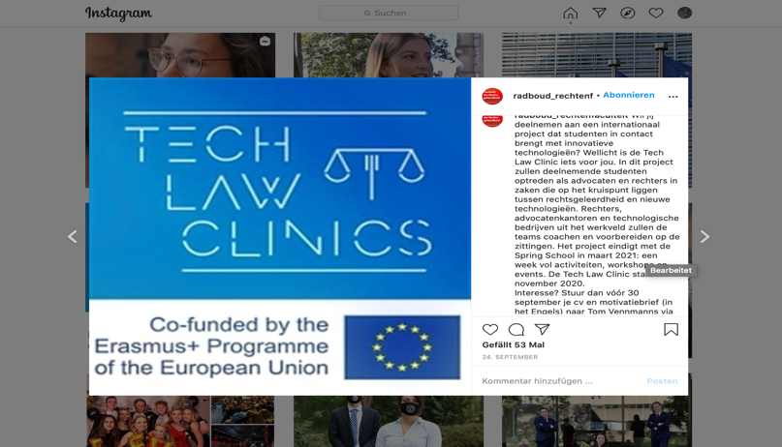
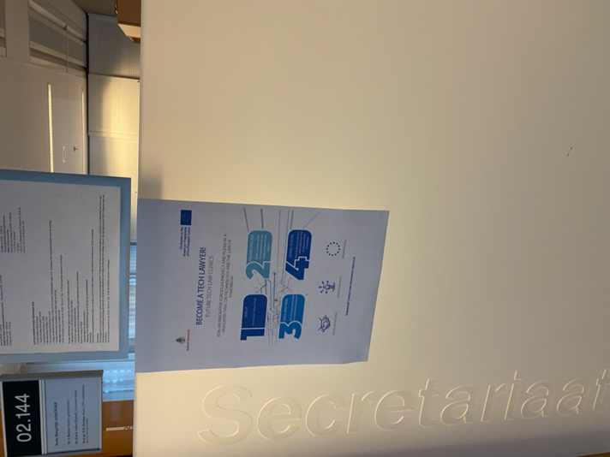

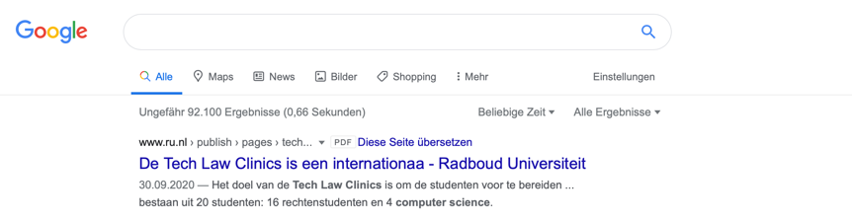

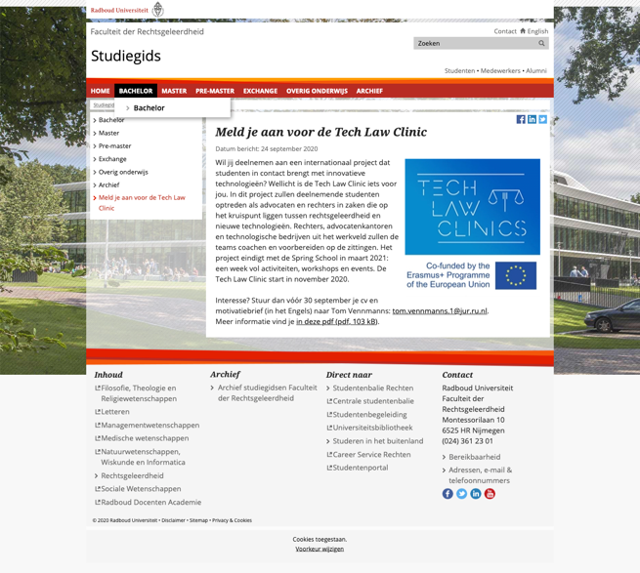
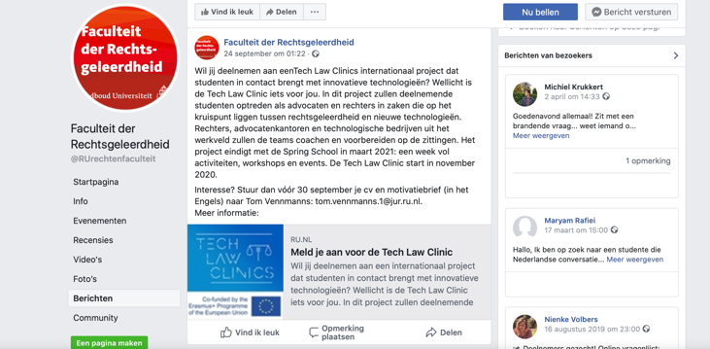

Writing and translation of this year’s case
The month of June 2019 has been devoted to write the case of this years TLC. While last year's case was mainly about autonomous driving and the problem of algorithmic discrimination, this year's case focuses on questions of tokenization, blockchain technology and the problem of accidental destruction of ERC-20 protocol tokens. The case was constructed by Pietro Ortolani and Tom Vennmanns and also serves the other universities as a basis for this year's Tech Law Clinic. In addition to questions of digitization, the case also focuses on Alternative Dispute Resolution, since questions about the binding nature of an arbitration award are also of enormous importance.
The case, originally written in Dutch, was also translated into English in June 2020. All partner universities have received the case.

Planning of this year´s Spring School
In addition, much effort has already been invested in planning the Spring School. The global corona situation leads to the assumption that in March 2021 no problem-free travel in Europe is possible. The teams of the four partner universities will therefore not be able to travel to Nijmegen. We have therefore agreed early on, in consultation with all partners, that a virtual/hybrid Spring School will take place from March 15-19, 2020. A detailed organizational plan (so-called Plan B) has already been drawn up and sent to all partners.
At various points, the Steering Committee held regular meetings to discuss the feasibility and planning of the Spring School.

Outline of lectures and meetings conducted at Radboud University
A number of educational activities were conducted at Radboud University. Some of the activities were lectures, as detailed below, while other activities were student-led meetings, where the students were divided in teams and discussed the case-study from the perspective of the claimant, the respondent or the judges. In addition, some organizational meetings were conducted.

Lectures/meetings

10 December 2020: Kick-off meeting
The first kick-off event will took place on 10 December 2020 in a physical setting in the main building of the Faculty of Law of the University of Nijmegen. During this meeting, the case was handed out, discussed in detail and the teams were formed.
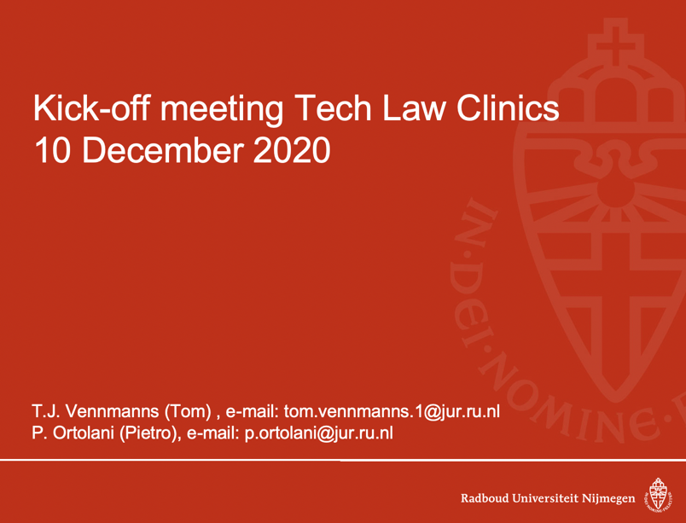

17 December 2020: Lecture on international arbitration
The first lecture, given by Prof. Pietro Ortolani (Radboud University), dealt with the concept and the rules of arbitration, as emerging from the case-study. Pietro Ortolani specializes in international arbitration and transnational dispute resolution. He holds a law degree from the University of Pisa and a Ph.D. in arbitration from LUISS Guido Carli University, Rome. Before joining Radboud University, he was a Senior Research Fellow at the Max Planck Institute Luxembourg for Procedural Law, a Research Associate at the University of Pisa and a Law Research Associate at Queen Mary, University of London. The lecture was a kind of crash course in international arbitration so that the students could deal with important legal issues in the case. The students were walked through the case-study and presented with a selection of relevant literature.
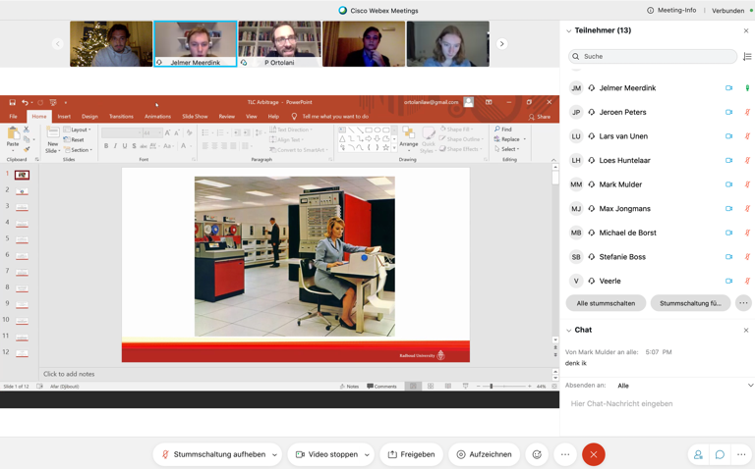

7 January 2020: Lecture on Online Dispute Resolution-mechanism (ODR)
The second lecture was delivered by Tom J. Vennmanns (Radboud University). As of June 2020 he works as a PhD-candidate Smart Contracts & Dispute Resolution at the faculty. Before joining Radboud University, he worked as a Research assistant at the Institute for International Business Law/Chair of Civil Law, Philosophy of Law and Private International Law at Westfälische Wilhelms-Universität Münster, worked in various international law firms in the Netherlands and Germany and gained experience in the European Parliament. During the lecture, the basic features and practical application possibilities of ODR procedures were discussed. Not only legal questions were answered, but also the technical functioning of ODR procedures was explained. In particular, the advantages of ODR procedures compared to traditional court proceedings were an crucial issue during this lecture. 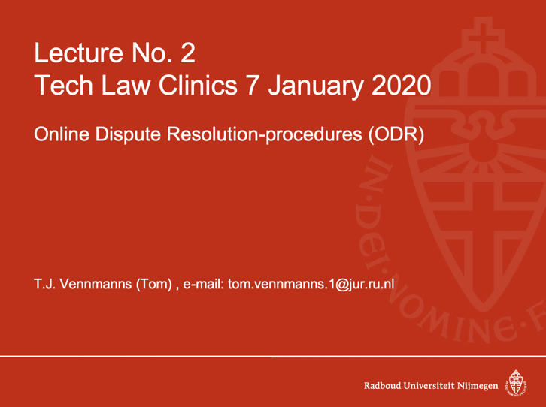

14 January 2020: Jur AG Court Layer Simulation
In the third lecture, the partner company of TLC Jur AG presented the in-house ODR tool Court Layer. The Jur Court Layer is an ODR procedure that works according to the principles of international arbitration. The Court Layer plays an essential role in the case, which is why Jur offered a very detailed explanation and simulation of the legal tech tool.
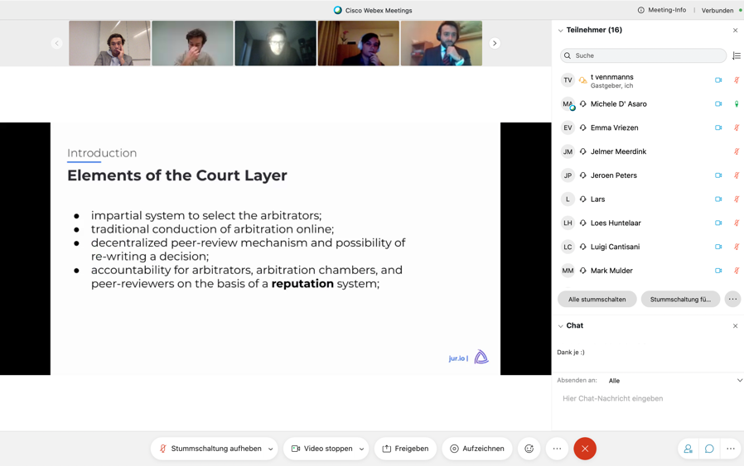

21 January 2020: Smart Contracts and the new digital directives
The fourth lecture was delivered by Prof. André Janssen (Radboud University). Prof. Janssen is an expert in the field of civil law, in particular contracts and torts, European private law, international sales law and artificial intelligence and law. He is editor-in-chief of the European Review of Private Law (ERPL) and director of the German-Dutch Lawyers' Conference. In his presentation, he talked about the basic principles of smart contracts and the two new EU digital directives (Directive (EU) 2019/770 and 2019/771). Prof. Janssen explained the functionality and areas of application and discussed open legal questions regarding the new directives. An open discussion was held in which the students were asked to share their own views on the issues.
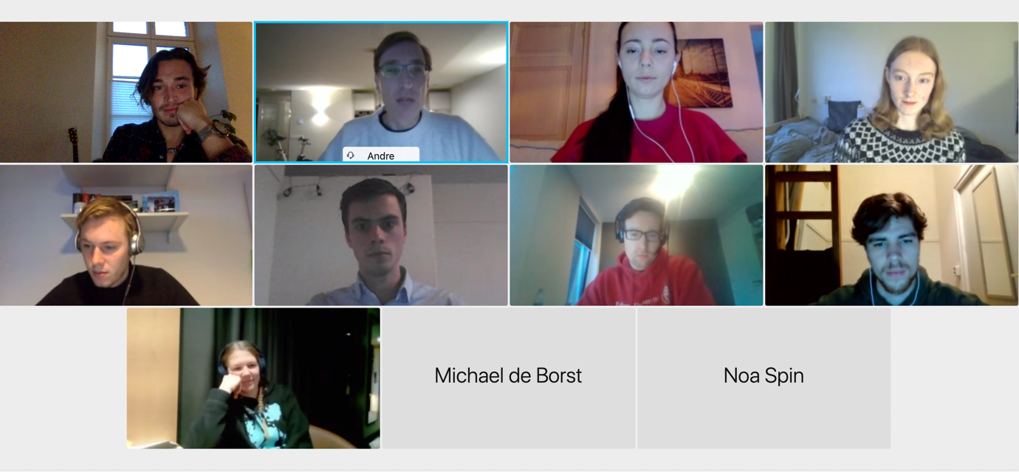

4 February 2020: Tokens and Fintech
The fifth lecture addressed questions on tokens, fintech and the tokenization of real estate property. The lecture was given by Dr. Claudia Sandei. Claudia Sandei is Associate Professor of Technology Law and Corporate Law at the University of Padova, Director of Innovation and Technology Law Lab (ITLL), Co-founder and Managing Director of the Digital Law Network (DNL). Central questions of this year's case revolve around aspects of financing real estate projects with the help of tokens. She discussed the blockchain as the technical basis of tokens and explained the many different applications of tokens.
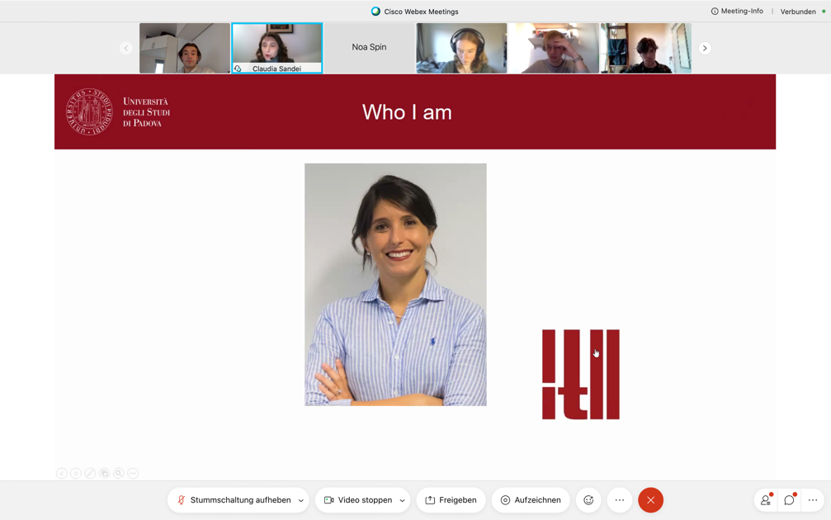

18 February 2020: Competition law and digital markets
Since mainly civil law aspects of the digitalization of law were dealt with in the preceding lectures, the students should also be given an outlook regarding public law problems. Dr. Catalin Rusu (Radboud University) spoke about EU competition law in digital markets. Catalin S. Rusu works as Associate Professor of European Law at Radboud University Nijmegen, where he lectures on EU (Economic) Law, EU Competition Law, and EU Internal Market Law, at bachelor and master levels. He is also Visiting Professor of European Competition Law at the Faculty of Law of 'Babes-Bolyai' University, Cluj Napoca. He explained the main features of EU competition law and discussed the problems of applying these rules to digital markets.
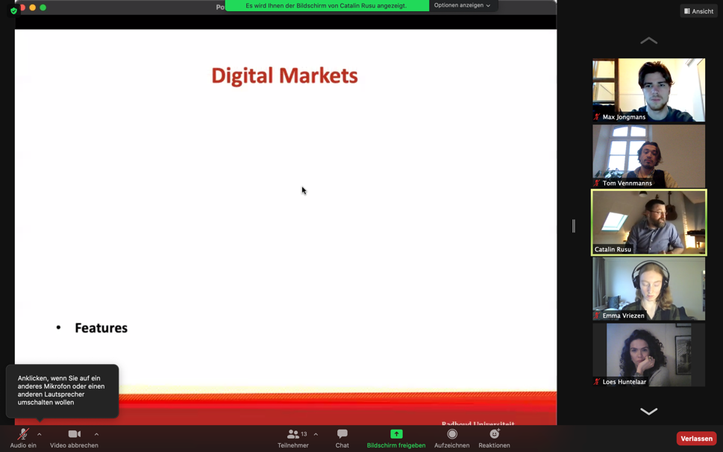

25 February 2020: EU data protection and security rights
The last lecture was given by Dr. Raphaël Gellert. Raphael Gellert is an assistant professor in private law and ICT at the law faculty of the Radboud University, Nijmegen. The core of his research revolves around the regulation of technologies, and in particular digital technologies, which he conducts in an interdisciplinary fashion. He gave the students an insight into the main features of EU data protection law. He discussed important legal instruments such as the EU Charter and the EU General Data Protection Regulation. The last lecture was also very interactive, as the students were asked to compare the legal aspects discussed with their own experiences regarding the use of cookies and personal data, etc. The students were also given the opportunity to discuss their own experiences.
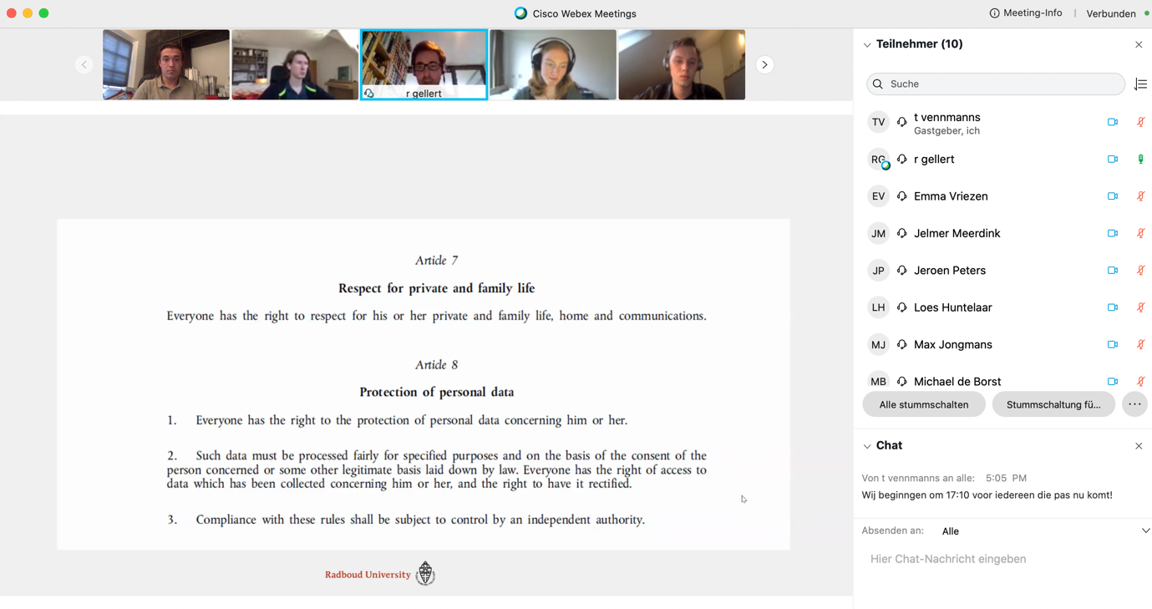

Team Meetings
The students scheduled weekly meetings with the members of the teams they belonged to (claimant, respondent, or judges). While the students were left free to organize the meetings at their convenience and according to their schedules, PhD candidate Tom Vennmanns supervised them and provided guidance where needed. Two types of activities, in particular, required supervision. First, the drafting of the written memoranda and of the judgment raised a number of issues. Here, Tom Vennmanns met with the students every week via Webex to discuss and solve each team's work progress, questions and problems.

Spring School Organizational Meeting
On 4 March, the students met with Dr. Ortolani, Tom Vennmanns and Ms. Loes Spiertz from the International Office of the Faculty of Law, to discuss the logistics of the Spring School. Originally, the aim of this meeting was to give the students some practical information about the flights, and transfers to and from the airports, and the accommodation. To this end, bundles with all the necessary information were created and distributed to each student. Unfortunately, however, the news about the spreading of the coronavirus gained prominence in the days before the meeting. For this reason, the meeting became also a chance for the students to meet with the project coordinator and with a member of the University administration, to discuss personal concerns and preferences. Having a meeting in person helped greatly in managing the students’ expectations, and giving them some personal guidance. It is a best practice that should be replicated, in the years to come.

Drafting of written memoranda and judgment
In the months of January and February 2020, the students were involved in the drafting of three documents related to the case-studies. The two teams acting as counsels for claimant and respondent drafted two statements, respectively of claim and defence. The judges, instead, drafted a judgment, deciding the legal dispute and in particular taking a position on the five issues identified in the procedural order on December 2020 (see above).
Each student sent their drafts to Tom Vennmanns who commented on each draft extensively in writing. The students were then asked to address the comments in a new version of the drafts, and to collaborate with each other to ensure consistency among the different parts of the memoranda and judgment, and an efficient division of labour. Tom Vennmans met with the students on a weekly basis (via Zoom), to ensure they grasped both the legal and the technical questions raised by the case-study. Once all students improved their individual drafts, the results were consolidated in the final documents containing the statement of claim, statement of defence, and judgment.

Visit to associated partner
Due to the Corona lockdown in the Netherlands, which lasted for the entire duration of the TLC, it was unfortunately impossible to conduct guest visits. We hope that the situation will ease in the future so that this will be possible again next year.

