TECH LAW CLINICS 2021
PROCEDURAL ORDER No. 1

CLAIMANT
Mr. John Sloterdijk

----------------------------------------------

AGAINST
Berliner Wohnungsbaugesellschaft

TABLE OF CONTENTS

Contents
FACTUAL BACKGROUND 3
THE DISPUTE 5
THE COURT’S ORDER 7

FACTUAL BACKGROUND

The present proceedings were initiated by Mr. John Sloterdijk, a Dutch citizen residing in the Dutch city of Nijmegen (hereinafter ‘CLAIMANT’) against Berliner Wohnungsbaugesellschaft, a German company seated in the German city of Berlin (hereinafter ‘RESPONDENT’). According to the parties’ initial submissions to the Court, the following facts must be considered as undisputed between the parties.

RESPONDENT is a German real estate developer, specialized in the construction and rental of city apartments in the German city of Berlin. Due to the growing interest of non-German citizen to visit Berlin, RESPONDENT has focused the company activities on foreign nationals who want to spend short periods of time in the city. RESPONDENT does not only build real estate, but also manages the short-term rental of the properties, and deals with all burdens coming up (e.g. the cleaning of the rented properties and the administrative management thereof).

In 2017, RESPONDENT presents a project aimed to build a luxury apartment complex with ten identical flats. In order to finance this project, RESPONDENT does not resort to traditional project finance channels. Instead, RESPONDENT advertises the project on its website, announcing that it will conduct a so-called “Initial Token Offering” (ITO). According to the information published on RESPONDENT’s website, private investors will be given the possibility to purchase “Apartment Revenue Tokens” (ARTs), circulating on the Ethereum blockchain. According to RESPONDENT’s terms and conditions, the purchase price is to be paid in Ether (ETH), the cryptocurrency of the Ethereum blockchain. The price of each ART is 150 ETH.

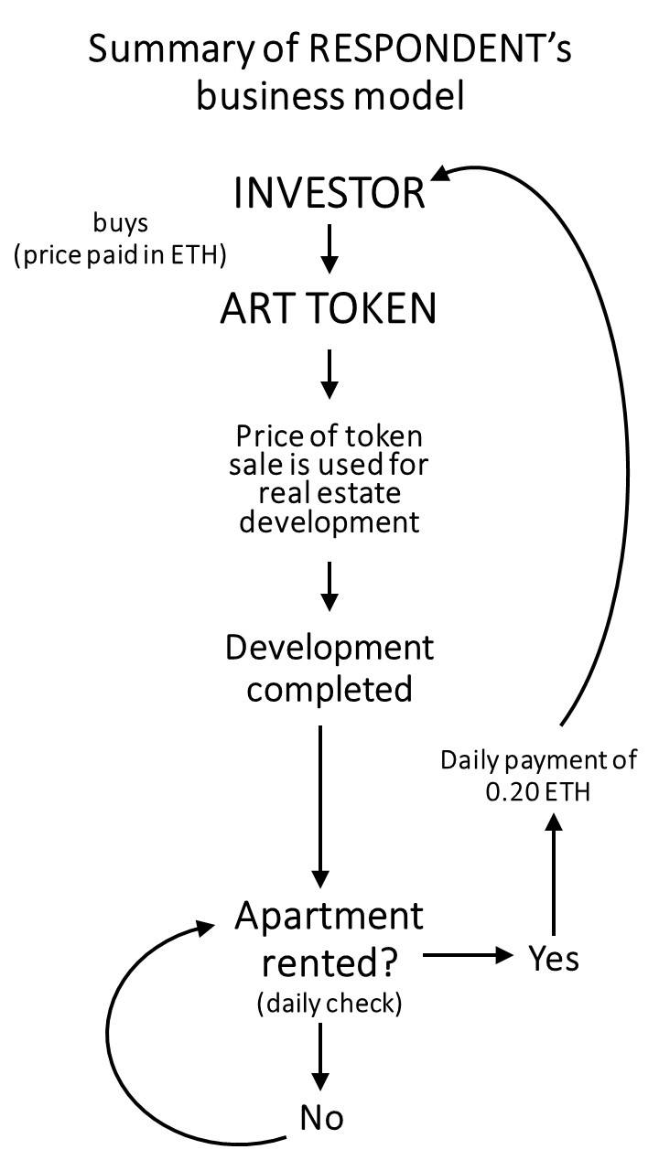
Each ART is linked to one of the apartments in the complex built by RESPONDENT. Pursuant to RESPONDENT’s general terms and conditions, the holder of each ART is entitled to receive a payment of 0.20 ETH for each of the days in which the relevant apartment is rented, for a period of four years, starting from the date of completion of the real estate development project (1 January 2020). The daily payments are automated through the Apartment Revenue Smart Contract (ARSC), a software script deployed on the Ethereum blockchain. On a daily basis, the ARSC retrieves independently verified information as to whether the apartment has been rented in the previous 24 hours. If the apartment has been rented, the ARSC makes a payment of 0.20 ETH to the Ethereum wallet in which the relevant ART is being held. In other words, the smart contract automatically detects whether the apartment has been rented on the previous day, and transfers a predetermined amount of money to the investor holding the ART connected to that apartment.

Like many other tokens existing on the Ethereum blockchain, ARTs follow the ERC20 protocol. This means that the tokens’ functioning and exchange are governed by a set of standard rules, encoded on the Ethereum blockchain. The ERC20 protocol can be understood as a set of rules, regulating how tokens can be transferred and used by the tokenholder.

CLAIMANT and RESPONDENT have concluded a token sale contract. Under this contract, CLAIMANT purchases one ART, transfers 150 ETH to RESPONDENT, and receives 1 ART in exchange. As a result of this transaction, CLAIMANT’s Ethereum wallet now contains 1 ART, as well as a certain amount of ETH, that CLAIMANT uses routinely to make other payments unrelated to the transaction with RESPONDENT.

Starting from 1 January 2020, CLAIMANT starts receiving the sum of 0.20 ETH on his wallet, automatically transferred by the ARSC for each day in which the apartment linked to CLAIMANT’s ART is rented, as promised by RESPONDENT in its terms and conditions and in the token sale contract.

THE DISPUTE

On 10 June 2020, CLAIMANT accesses his Ethereum wallet, to finalize a transaction unrelated to the present dispute. In the context of this unrelated transaction, CLAIMANT intends to deposit the sum of 1 ETH into a smart contract. CLAIMANT, however, commits a mistake. Instead of sending 1 ETH to the smart contract, he accidentally selects the ART, and sends the token to the smart contract. The smart contract in question is not compatible with ERC20 tokens. Due to a well-known characteristic of the ERC20 standard, it is impossible to retrieve tokens accidentally sent to a smart contract that is not compatible with tokens. As a result, CLAIMANT’s ART is essentially destroyed and unrecoverable.

Starting from 11 June 2020, CLAIMANT stops receiving daily payments from RESPONDENT, even if the apartment connected with the lost ART continues to be rented. CLAIMANT’s contacts RESPONDENT and asks to keep receiving the payments. RESPONDENT answers that CLAIMANT is no longer entitled to receive the payments, now that the ART has been destroyed.

The token sale contract between the RESPONDENT and CLAIMANT contains the following dispute resolution clause:

“All disputes arising out of or in connection with the present Contract shall be finally settled by a procedure under the Jur Court Layer. The Jur Court Layer is an online dispute resolution (“ODR”) mechanism. The parties accept the functioning and the rules of procedure of the Jur Court Layer, as laid down on the Jur website.“

Moreover, the token sale contract contains the following applicable law clause:

“The parties’ entire relationship is governed by this contract (including the ARSC), and by the general principles of the Blockchain community, as enshrined in the relevant technical standards“

CLAIMANT commences the dispute resolution procedure via the Jur Court Layer, as provided for in the token sale contract, and asks for payment for the days in which the apartment was rented after the destruction of the ART.

The rules of procedure for the Jur Court Layer provide that the dispute will be resolved by a panel of three adjudicators, selected randomly by an algorithm. The procedure is conducted entirely online through written submissions, and no oral hearing is held.

At the end of the Jur Court Layer procedure, the panel finds that CLAIMANT is not entitled to receive any payment for the period after 10 June 2020. The panel’s final decision is contained in a PDF document, delivered to the parties through electronic means. In it, the panel rules that RESPONDENT is not responsible for the destruction of the token, nor for the technical flaws of the ERC20 technology.

After losing the Jur Court Layer procedure, CLAIMANT commences the present proceedings. CLAIMANT asks that RESPONDENT be ordered to pay the sum of ETH 0.20, or the corresponding amount in Euros, for each day in which the apartment linked to the destroyed ART has been rented, in the period after 10 June 2020, and up until 31 December 2024.

RESPONDENT appears in the present proceedings and argues that:
- the case is res judicata, as it has already been finally decided in the context of the Jur Court Layer procedure, which qualifies as a form of binding arbitration;
- In the alternative, should the Court hold that the case is not res judicata, CLAIMANT’s prayer for relief should be declined, because:
- The law applicable to the contract is the ERC20 protocol. It is well known within the blockchain community that the ERC20 protocol does not offer a remedy, for the type of mistake that CLAIMANT has committed.
- Under the ARSC, CLAIMANT is only entitled to the daily payments if he holds the relevant ART in his wallet, and this is no longer the case as of 10 June 2020.

THE COURT’S ORDER

In light of the above, the Court orders that the parties submit their statements of claim and defence before DATE. The Court invites the parties to address the following issues in their statements:
- Is the case res judicata? With specific reference to the questions whether:
- the Jur Court Layer procedure, where the adjudicators are selected by an algorithm, can be qualified as arbitration;
- the Jur Court Layer procedure, where no oral hearings are conducted, can be qualified as arbitration;
- the outcome of the Jur Court Layer procedure can be recognized in these court proceedings as a binding arbitral award;
- What is the law applicable to the token sale contract?
- What is the relevance of the ARSC in the interpretation of the contract between the parties, and in the determination of the scope of the obligations arising therefrom?

https://github.com/ethereum/EIPs/issues/20.
https://medium.com/@ethex.smm/problems-and-issues-of-erc-20-token-standard-9c92cbdea389.
https://bit.ly/jur-wp-v203. See also: https://jur.io/products/court-layer/.

